**Ender 3 Spec Personal Notes**

**Power Supply**

24V 15A 360W Power Supply, upgrading power supply is recommended if we decided to use higher wattage hot end heater cartridge.

Having 24V 20 / 25A power supplies good.

**Stepper Motors**

NEMA 34 Stepper Motor for XYZ axis ~ MAX Load 25W

NEMA 40 Stepper Motor for Extruder ~ MAX Load 25W

Stepper Motor Driver : A4988 for all Steppers

**High Current Drivers**

D522 MOSFET Continuous Current ~10A on FLAT rate temperature range, it can dissipate upto 100W

D522 Drives FAN, Hotend and Heated Bed, so same model MOSFET is used for higher wattage heated bed means we have very good margin.

**Heater Cartridge**

6mm Dia and 20mm length Heater Cartridge.

Default 24V 40W spec, given the MOSFET and Power Supply spec we can go up to 24V 80W Heater Cartridge easily.

Default Nozzle Heater Cartridge 24V，40W

Thermistor model : EPCOS 100K Thermistor (B57560G1104F)

**Heated Bed**

Heated Bed 24V 220W. [24V，235*235mm，220W]

**Power Usage**

5V ~ 1.5A, So do not directly draw any more 5V power from motherboard.

360 = 220W - 80W - 60W (assuming X, Y, Z, E & Other Electronics consumption).

Since default configuration allocates 100W for X, Y, Z, E & Other Electronics consumption, this needs to be measured.

**LCD Type**

LCD : 10 Pin Standard 3D Printer LCD Connector

<https://reprap.org/wiki/Thermistor#EPCOS_100K_Thermistor_.28B57560G1104F.29>

**Notes**

E3D Type hot end requires printing mount

CR10 Hotend type does not require any mount printing.

So reasonable upgrade for Ender 3 will be

Getting new Heater Cartridge and if required then power supply.

Most of the time the speed of the print going to be bottlenecked by Hotend wattage. Because Ender 3 uses the wheeled XY movement which is much faster than other methods and well calibrated then it stress very little load.

OctoPi + klipper is best WIFI configuration and archives very good speed.

Marlin 2.0 will be good option

Power Consumption Analysis

<http://cockeyed.com/incredible/3D_printer/3D_printer_power.html>

**Z-Rod**

T8 365mm

**XY Timing Belt**

Type: 2GT

GT2 Pitch: 2mm

Belt Height: 1.38mm

Tooth Height: 0.75mm

Material: Rubber

X axis Belt Length: 786mm

Y axis Belt Length: 743mm

Width: 6mm

Pully X, Y Stepper Motor 2GT-d5-20 teeth - 6mm

**Extruder Pully**

Model Number:40 Teeth Mk7 / Mk 8 Brass Planetary Gear Wheel  
Material:Brass  
The number of teeth:40 teeth  
Use For :3D printer  
Specification:5mm*11mm*11mm

**FAN**

4010 Blower 40x40x10MM 24V DC Cooling Fan and

4010 40x40x10MM 24V Circle Fan For Nozzle Heat Sink Cooling

Case Fan 24V-4010-L150mm

**Wheels and Bearings**

V-Slot POM Wheels 24mm, Inner diameter: 5mm, Height: 11mm / 625ZZ v-slot POM wheel

3D Printer U Guide [624U] for extruder

X & Y Axis Idler Pully F688-2Z F688ZZ F688 zz F628/8ZZ Flanged Flange Deep Groove Ball Bearings 8 x 16 x 5mm for 3D printer

**XYZ Stepper Motor [JK42HS34-0844YA-03F]**

JK: JKong Motor (brand)  
42: Width of the motor (~42mm, 1.7", meaning NEMA 17)  
H: Probably just "Hybrid", since that's what they list the type of these steppers as...but not 100% sure.  
S: S = 1.8 degrees/step, M = 0.9 degrees/step  
34: Length of the motor body (in mm)  
084: Current/Phase (0.84A here)  
4: Number of wires to control the motor  
YA: ???  
03F: ???

**Extruder Stepper Motor [JK42HS40-1004AC-01F]**

JK: JKong Motor (brand)  
42: Width of the motor (~42mm, 1.7", meaning NEMA 17)  
H: Probably just "Hybrid", since that's what they list the type of these steppers as...but not 100% sure.  
S: S = 1.8 degrees/step, M = 0.9 degrees/step  
40: Length of the motor body (in mm)  
100: Current/Phase (1.00A here)  
4: Number of wires to control the motor  
AC: ???  
01F: ???

**Z Lead Screw**

3D Printer T8 8mm Rod Lead Screw 365 mm / 8mm Lead Screw

Screw spacing: 2mm  
Lead of thread: 8mm  
Range: Reprap makerbot 3d printer accessories 3D engraving machine lead screw 400mm length with nut.  
Nut turn an around move 8m

**Heat Break Spec**

Ender 3 Stock Heat Break

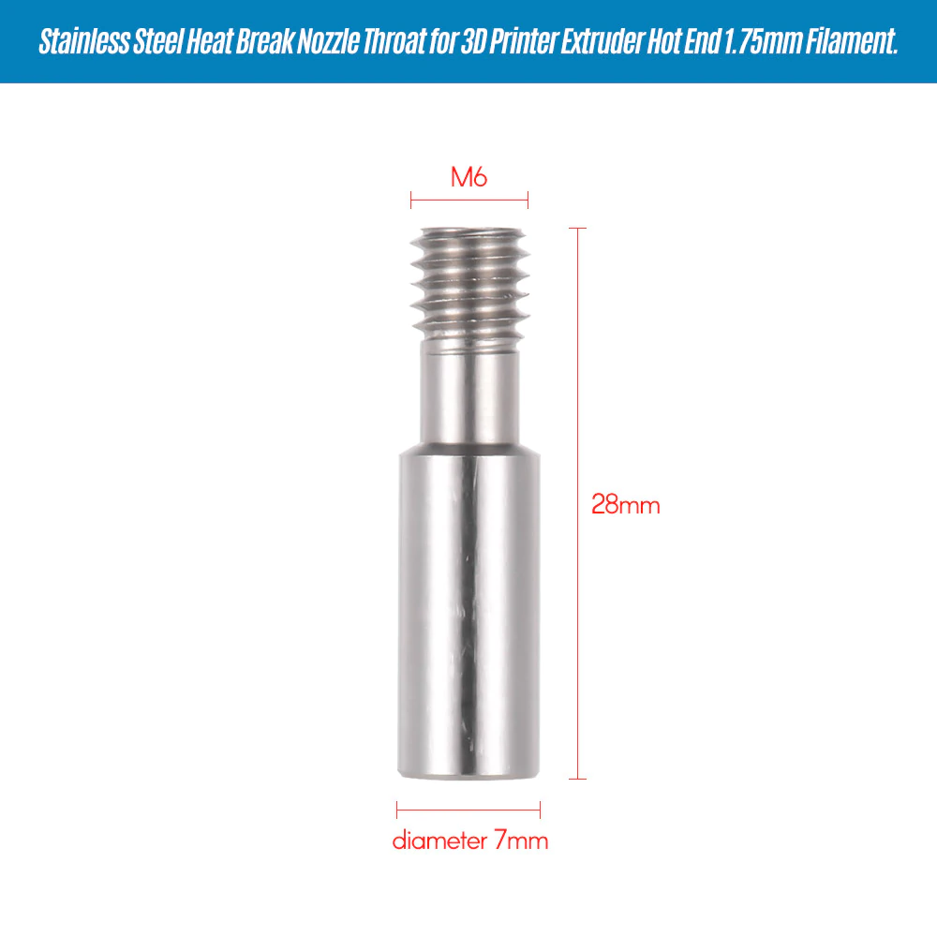

**E3D Heat Break**

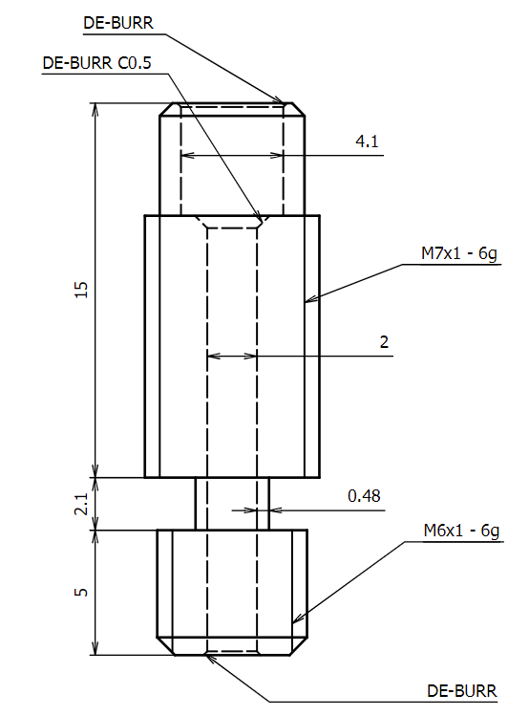

Throat Diameter must be ~ 2.48 to 2.50mm

Whole diameter ~2.00mm